Source Code:

import cv2

import matplotlib.pyplot as plt

import math

img = cv2.imread('/Users/louis/Downloads/Bird feeding 3 low contrast.tif')

cv2.imshow('Original', img) *#show image*

plt.hist(img.ravel(),256,[0,256])

plt.show() *#show histogram*

a=img.shape

for i in range(a[0]):

for j in range(a[1]):

temp=img.item(i,j,0)

new=math.atan((temp-128)/32)*96.2343+127.589

img.itemset((i,j,0),new)

img.itemset((i,j,1),new)

img.itemset((i,j,2),new)

print("r=",temp," s=",new)

cv2.imshow('Revised', img) *#show revised image*

plt.hist(img.ravel(),256,[0,256])

plt.show() *#show new histogram*

cv2.waitKey(0)

cv2.destroyAllWindows()

Figure of s=T(r)

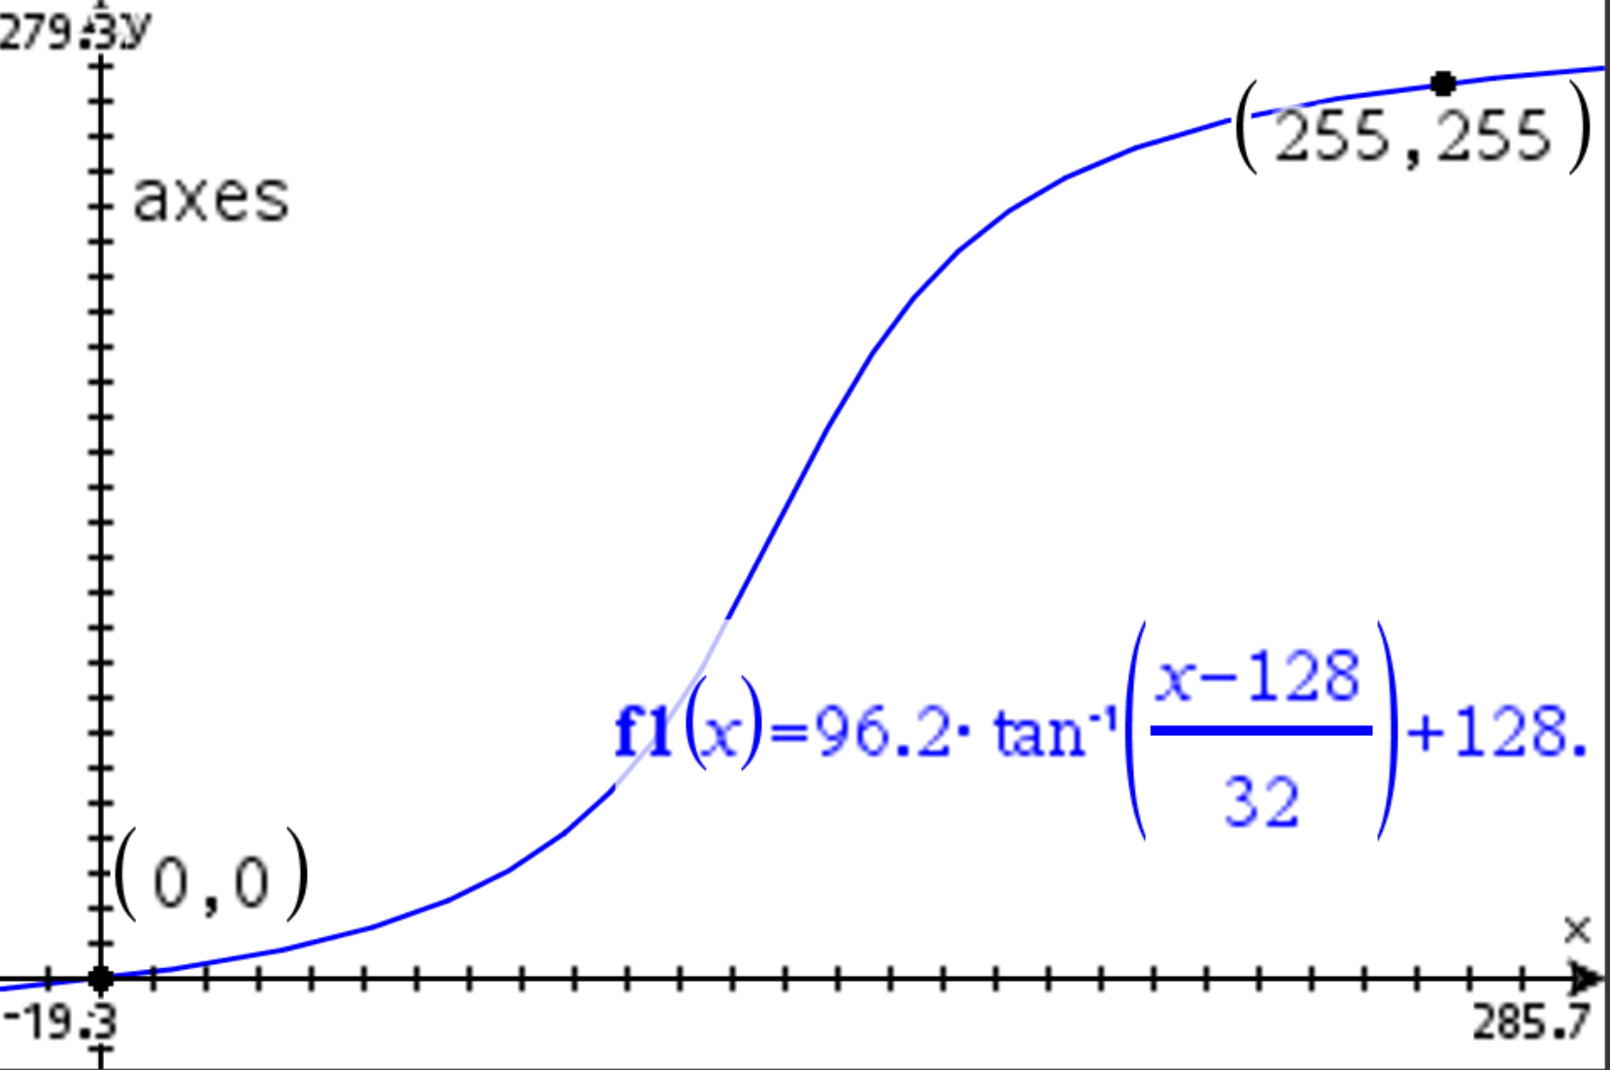

Table of transformation function to show the mapping from the input gray level r to

the output gray level s

| 1 | 0.1780766722 |
| --- | --- |
| 2 | 0.3589467517 |
| 3 | 0.5425340812 |
| 4 | 0.7288989898 |
| 5 | 0.9181035629 |
| 6 | 1.110211705 |
| 7 | 1.305289202 |
| 8 | 1.503403796 |
| 9 | 1.704625249 |
| 10 | 1.90902542 |
| 11 | 2.116678341 |
| 12 | 2.327660299 |
| 13 | 2.54204992 |
| 14 | 2.759928251 |
| 15 | 2.98137886 |
| 16 | 3.206487923 |
| 17 | 3.435344329 |
| 18 | 3.66803978 |
| 19 | 3.904668902 |
| 20 | 4.145329356 |
| 21 | 4.39012196 |
| 22 | 4.639150808 |
| 23 | 4.8925234 |
| 24 | 5.15035078 |
| 25 | 5.412747676 |
| 26 | 5.679832645 |
| 27 | 5.951728231 |
| 28 | 6.228561124 |
| 29 | 6.510462332 |
| 30 | 6.797567354 |
| 31 | 7.090016368 |
| 32 | 7.387954425 |
| 33 | 7.691531652 |
| 34 | 8.000903461 |
| 35 | 8.316230778 |
| 36 | 8.637680272 |
| 37 | 8.965424598 |
| 38 | 9.29964266 |
| 39 | 9.640519871 |
| 40 | 9.988248439 |
| 41 | 10.34302766 |
| 42 | 10.70506423 |
| 43 | 11.07457257 |
| 44 | 11.45177514 |
| 45 | 11.83690285 |
| 46 | 12.23019537 |
| 47 | 12.63190157 |
| 48 | 13.0422799 |
| 49 | 13.46159881 |
| 50 | 13.89013725 |
| 51 | 14.32818509 |
| 52 | 14.77604364 |
| 53 | 15.23402614 |
| 54 | 15.70245834 |
| 55 | 16.18167903 |
| 56 | 16.67204065 |
| 57 | 17.17390989 |
| 58 | 17.68766837 |
| 59 | 18.21371329 |
| 60 | 18.75245812 |
| 61 | 19.30433336 |
| 62 | 19.8697873 |
| 63 | 20.4492868 |
| 64 | 21.04331815 |
| 65 | 21.65238786 |
| 66 | 22.27702363 |
| 67 | 22.91777521 |
| 68 | 23.57521537 |
| 69 | 24.24994086 |
| 70 | 24.94257344 |
| 71 | 25.65376086 |
| 72 | 26.38417795 |
| 73 | 27.13452766 |
| 74 | 27.90554211 |
| 75 | 28.69798369 |
| 76 | 29.51264613 |
| 77 | 30.35035555 |
| 78 | 31.21197147 |
| 79 | 32.09838786 |
| 80 | 33.010534 |
| 81 | 33.94937543 |
| 82 | 34.91591468 |
| 83 | 35.91119193 |
| 84 | 36.93628551 |
| 85 | 37.99231226 |
| 86 | 39.08042758 |
| 87 | 40.20182533 |
| 88 | 41.3577373 |
| 89 | 42.54943242 |
| 90 | 43.77821544 |
| 91 | 45.04542516 |
| 92 | 46.35243205 |
| 93 | 47.70063526 |
| 94 | 49.09145874 |
| 95 | 50.52634662 |
| 96 | 52.00675752 |
| 97 | 53.53415783 |
| 98 | 55.11001368 |
| 99 | 56.7357817 |
| 100 | 58.41289817 |
| 101 | 60.14276666 |
| 102 | 61.92674396 |
| 103 | 63.76612424 |
| 104 | 65.66212125 |
| 105 | 67.61584872 |
| 106 | 69.62829885 |
| 107 | 71.70031884 |
| 108 | 73.83258591 |
| 109 | 76.02558058 |
| 110 | 78.27955896 |
| 111 | 80.59452405 |
| 112 | 82.9701969 |
| 113 | 85.405988 |
| 114 | 87.90096984 |
| 115 | 90.45385143 |
| 116 | 93.06295569 |
| 117 | 95.72620083 |
| 118 | 98.44108671 |
| 119 | 101.2046873 |
| 120 | 104.0136498 |
| 121 | 106.8642025 |
| 122 | 109.7521698 |
| 123 | 112.672997 |
| 124 | 115.6217841 |
| 125 | 118.5933274 |
| 126 | 121.5821695 |
| 127 | 124.5826565 |
| 128 | 127.589 |
| 129 | 130.5953435 |
| 130 | 133.5958305 |
| 131 | 136.5846726 |
| 132 | 139.5562159 |
| 133 | 142.505003 |
| 134 | 145.4258302 |
| 135 | 148.3137975 |
| 136 | 151.1643502 |
| 137 | 153.9733127 |
| 138 | 156.7369133 |
| 139 | 159.4517992 |
| 140 | 162.1150443 |
| 141 | 164.7241486 |
| 142 | 167.2770302 |
| 143 | 169.772012 |
| 144 | 172.2078031 |
| 145 | 174.5834759 |
| 146 | 176.898441 |
| 147 | 179.1524194 |
| 148 | 181.3454141 |
| 149 | 183.4776812 |
| 150 | 185.5497012 |
| 151 | 187.5621513 |
| 152 | 189.5158788 |
| 153 | 191.4118758 |
| 154 | 193.251256 |
| 155 | 195.0352333 |
| 156 | 196.7651018 |
| 157 | 198.4422183 |
| 158 | 200.0679863 |
| 159 | 201.6438422 |
| 160 | 203.1712425 |
| 161 | 204.6516534 |
| 162 | 206.0865413 |
| 163 | 207.4773647 |
| 164 | 208.8255679 |
| 165 | 210.1325748 |
| 166 | 211.3997846 |
| 167 | 212.6285676 |
| 168 | 213.8202627 |
| 169 | 214.9761747 |
| 170 | 216.0975724 |
| 171 | 217.1856877 |
| 172 | 218.2417145 |
| 173 | 219.2668081 |
| 174 | 220.2620853 |
| 175 | 221.2286246 |
| 176 | 222.167466 |
| 177 | 223.0796121 |
| 178 | 223.9660285 |
| 179 | 224.8276444 |
| 180 | 225.6653539 |
| 181 | 226.4800163 |
| 182 | 227.2724579 |
| 183 | 228.0434723 |
| 184 | 228.793822 |
| 185 | 229.5242391 |
| 186 | 230.2354266 |
| 187 | 230.9280591 |
| 188 | 231.6027846 |
| 189 | 232.2602248 |
| 190 | 232.9009764 |
| 191 | 233.5256121 |
| 192 | 234.1346819 |
| 193 | 234.7287132 |
| 194 | 235.3082127 |
| 195 | 235.8736666 |
| 196 | 236.4255419 |
| 197 | 236.9642867 |
| 198 | 237.4903316 |
| 199 | 238.0040901 |
| 200 | 238.5059594 |
| 201 | 238.996321 |
| 202 | 239.4755417 |
| 203 | 239.9439739 |
| 204 | 240.4019564 |
| 205 | 240.8498149 |
| 206 | 241.2878627 |
| 207 | 241.7164012 |
| 208 | 242.1357201 |
| 209 | 242.5460984 |
| 210 | 242.9478046 |
| 211 | 243.3410971 |
| 212 | 243.7262249 |
| 213 | 244.1034274 |
| 214 | 244.4729358 |
| 215 | 244.8349723 |
| 216 | 245.1897516 |
| 217 | 245.5374801 |
| 218 | 245.8783573 |
| 219 | 246.2125754 |
| 220 | 246.5403197 |
| 221 | 246.8617692 |
| 222 | 247.1770965 |
| 223 | 247.4864683 |
| 224 | 247.7900456 |
| 225 | 248.0879836 |
| 226 | 248.3804326 |
| 227 | 248.6675377 |
| 228 | 248.9494389 |
| 229 | 249.2262718 |
| 230 | 249.4981674 |
| 231 | 249.7652523 |
| 232 | 250.0276492 |
| 233 | 250.2854766 |
| 234 | 250.5388492 |
| 235 | 250.787878 |
| 236 | 251.0326706 |
| 237 | 251.2733311 |
| 238 | 251.5099602 |
| 239 | 251.7426557 |
| 240 | 251.9715121 |
| 241 | 252.1966211 |
| 242 | 252.4180717 |
| 243 | 252.6359501 |
| 244 | 252.8503397 |
| 245 | 253.0613217 |
| 246 | 253.2689746 |
| 247 | 253.4733748 |
| 248 | 253.6745962 |
| 249 | 253.8727108 |
| 250 | 254.0677883 |
| 251 | 254.2598964 |
| 252 | 254.449101 |
| 253 | 254.6354659 |
| 254 | 254.8190532 |
| 255 | 254.9999233 |

Figure of the output image after applying the intensity transformation function

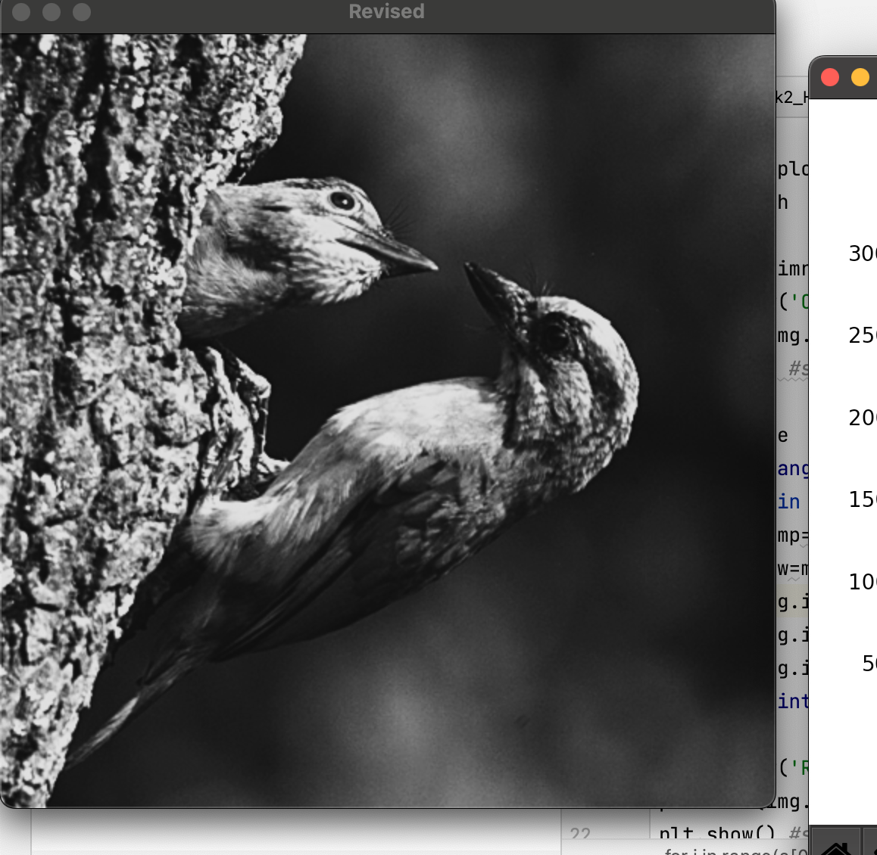

Figures of the original and output histograms

Original Histogram:

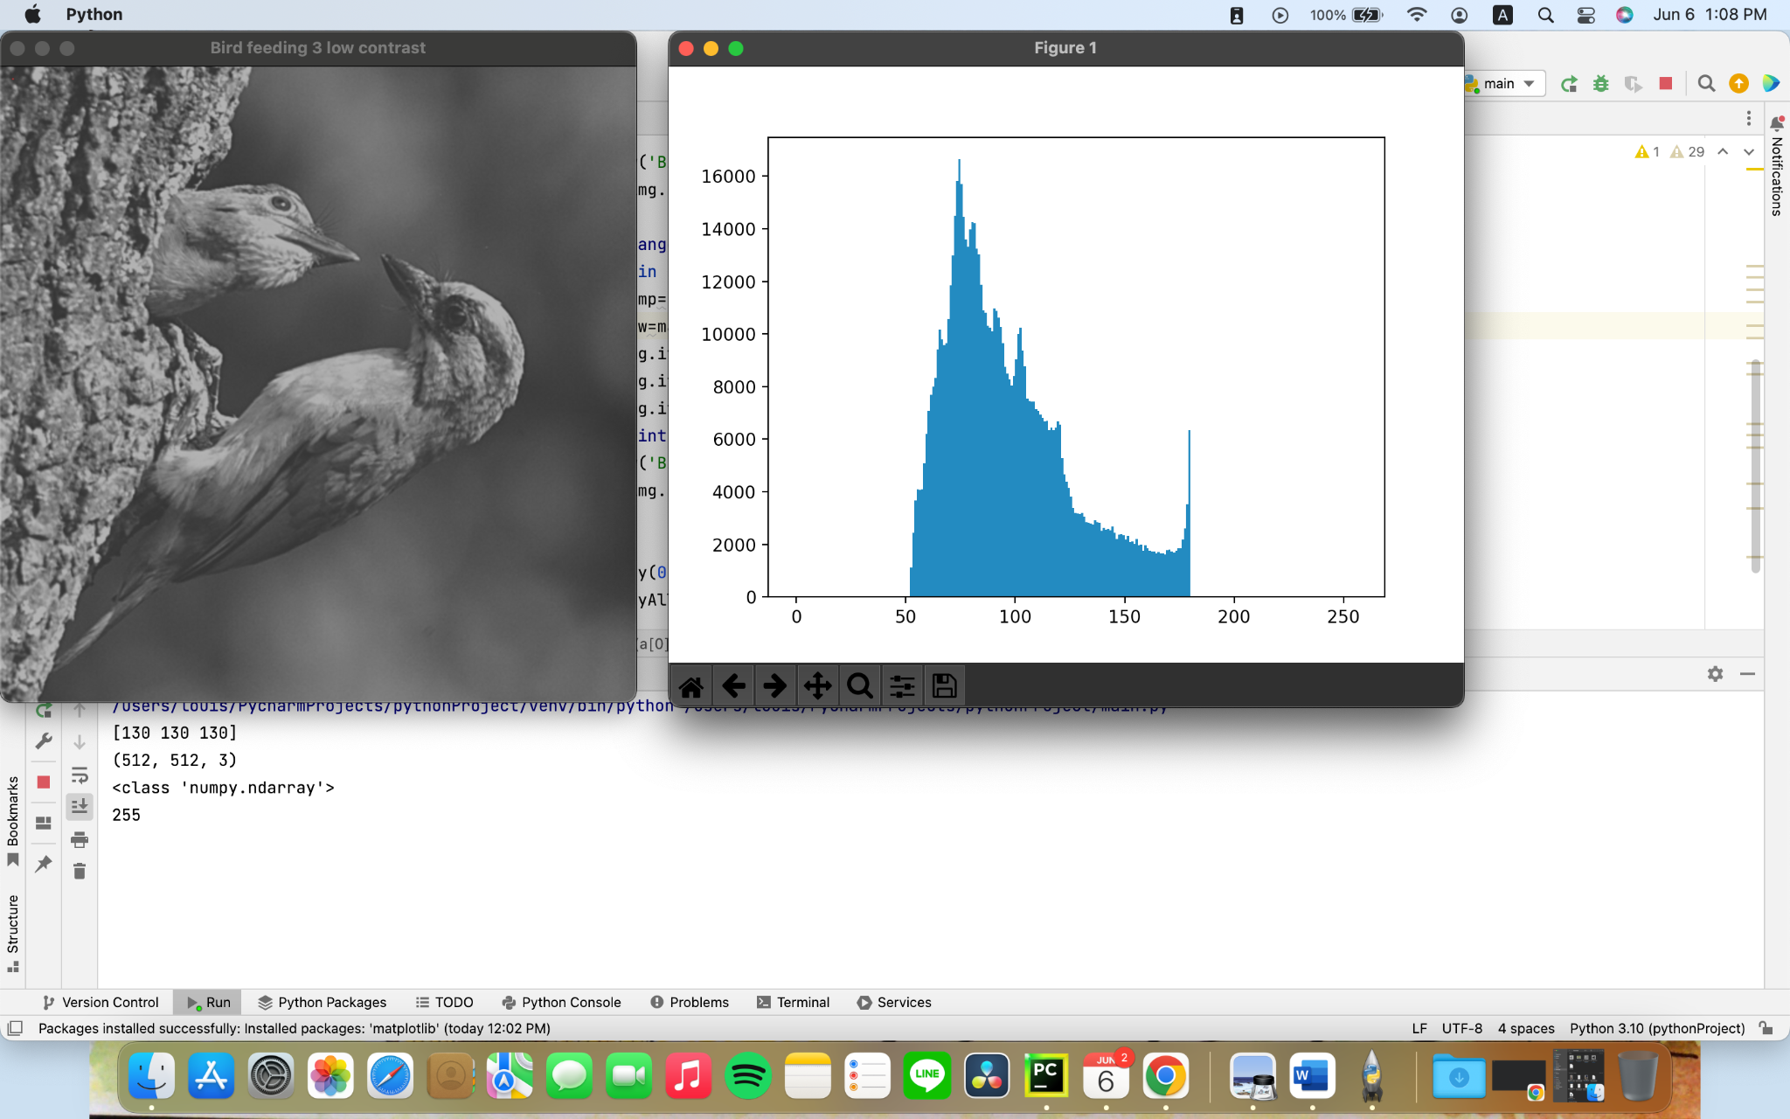

Changed Histogram:

